Smart Traffic Management System using AI

|  |  |  |
| --- | --- | --- |
| Ritik Kumar  *Department of CSE*  *Apex Institute of Technology*  *Chandigarh University, Punjab, India ritik0912kumar2003*@gmail.com  Rahul Kumar  *Department of CSE*  *Apex Institute of Technology*  *Chandigarh University, Punjab, India*  singhr78101@gmail.com | Deeplaksh Yadav  *Department of CSE*  *Apex Institute of Technology*  *Chandigarh University, Punjab, India*  deeplaksh2003@gmail.com  Ms. Tanvi  *Department of CSE*  *Apex Institute of Technology*  *Chandigarh University, Punjab, India*  tanvi.e15506@cumail.in | Sumit Yadav  *Department of CSE*  *Apex Institute of Technology*  *Chandigarh University, Punjab, India*  sumityadav131020@gmail.com |

***Abstract*— In today's world, managing traffic congestion and accidents is becoming increasingly difficult in the modern world due to the growing number of cars on the road. The efficiency of traffic and road safety management systems is greatly enhanced by artificial intelligence, especially machine learning algorithms. In this real world, artificial intelligence is used frequently to change the traditional system into an intelligent one. The Smart Traffic Management System which can identify dangerous driving practices and notify the concerned authorities is made to make changes in the road safety circumstances. Human activity monitoring in real-time is made possible by using the Internet of Things (IoT) and their respective sensors, which are used to recognize electrical impulses and other given inputs. Furthermore, Blockchain a new emerging technology will be used to automate transactions and used to secure transactions and communication between Internet of Things devices. Artificial Intelligence, on the other hand, will enable the system to make human-like decisions effectively disseminate information, and manage issues like accidents and other issues such as traffic congestion. This study proposes a Smart Traffic Management System that will be a combination of Artificial Intelligence, Blockchain, and the Internet of Things.**

**Keywords— *AI – Artificial Intelligence, ML – Machine Learning, SRTMS – Smart Road Traffic, Management System, IoT – Internet of Things, BC – Blockchain.***

# INTRODUCTION

To streamline traffic management some modern and upcoming technologies like driverless cars and smart roadways are linked with the help of the Internet of Things. The National Statistical Office [1] reports that India, a developing nation, experienced a 7.7% contraction in the 2020 fiscal year, compared to a 4.2% expansion in 2019. According to this research, India's progress has raised living standards despite the economic slump.

The demand for ITM systems has been fuelled by the rise in personal and commercial cars that accompany expansion, which has led to traffic congestion, delays in logistics, an increase in traffic accidents, and pollution [2]. It is challenging for authorities to efficiently control traffic in every city because of the labour-intensive nature of traditional, manually operated traffic systems and their ineffective traffic policies. To address traffic congestion, urban regions have implemented traffic signal systems. However, these systems ignore the dynamic nature of traffic flows and operate at set time intervals, resulting in inefficiencies and resource waste. Traffic and transport network management is getting harder as infrastructure and vehicle numbers increase. For example, there is usually a zebra crossing next to a traffic signal on every road, and the signal changes at a specific time [3]. When a route is empty but still obtains a green light, time is wasted since this conventional traffic system is unable to identify the presence of vehicles on all routes. Cities are therefore looking for better options, including an Intelligent Transport Management System (ITM).

ITM systems are commonly acknowledged as a solution to traffic management issues, aiding in the reduction of traffic and enhancing the quality of passenger and logistical transit. The degree to which IoT-based ITM systems improve people's quality of life determines how effective they are. A key element of ITM initiatives is smart-city governance, which emphasizes improved public services and policy planning. Mobile phones, sensors, and actuators are examples of smart gadgets that have progressed over the past few decades, allowing for sophisticated tasks and device-to-device communication. The IoT ecosystem is facilitated by the fact that almost every device, from wireless sensors to embedded systems, is linked to local networks or the Internet. The amount of data generated rises with the number of linked devices [5].

To create intelligent networks and facilitate communication, such as in ITM systems, IoT entails connecting physical objects to the internet. IoT-enabled vehicle communication is a key component of ITM and provides a new paradigm in information transmission. To efficiently manage traffic networks, IoT systems gather and examine sensor data [6]. Traditional traffic systems, on the other hand, including those that use timers for traffic signals, have limitations. Although widely use of electronic sensors for traffic management, traffic congestion and mismanagement still occur. On the other hand, the use of an Intelligent transport system can make a better traffic flow and address the problem [7].

The primary goal of smart cities is to create an urban environment that will help to maximize infrastructure usage and services with the help of Artificial Intelligence and Machine Learning. It will help to enhance the quality of life and resources which are available [8].

# LITERATURE REVIEW

A large set of datasets that are produced by several interlinked devices within the networks are being used by the Smart Traffic Management System. The available data is then processed by subsets of Artificial Intelligence (Deep Learning) to make traffic flow efficient. Cloud-based storage is used by Smart Traffic Management Systems and a Machine Learning Algorithm is used as described by researchers in [8].

By examining traffic volume and vehicle trends, a technique presented in [9] uses machine learning to optimize signal timing at crossings. To increase transportation efficiency, a decentralized reinforcement learning system in [13] forecasts signal durations based on traffic intensity. This study also suggests an environmentally friendly method that modifies signal timings according to vehicle density. In [9], an IoT-based smart water-quality monitoring system is examined, providing information on the potential uses of AI. Likewise, [10] investigates the use of AI-driven frameworks for air pollution monitoring to improve environmental health. An increasingly promising method for ITM is the use of vehicular ad hoc networks or VANETs. To lessen traffic, VANETs enable real-time vehicle communication and traffic data sharing [11].

To reduce congestion in in-vehicle communication networks, the study in [6] investigates a VANET-based strategy utilizing AODV protocols. For creative road traffic signalling, the system in [12] facilitates communication between vehicles and infrastructure. Vehicle flow and safety are enhanced by a VANET-enabled framework in [6], and a modular VANET-based solution is presented in [8]. Similarly, using GPS-enabled smartphone apps, [4] suggests a distributed approach for identifying and controlling high traffic. In [3] a layer of software which regulates the traffic lights with the help of vehicle frequency and sensor of Internet of Things System using cameras to track traffic.

The various tactics used to enhance traffic management are highlighted in this review. Every study offers a different strategy for addressing issues with traffic, road safety, and efficiency, ranging from cloud-based machine learning systems to IoT-enabled data collecting and VANET-based traffic control. Even though AI, IoT, and ML are essential parts of contemporary ITM systems, it is still quite difficult to integrate them into a thorough and expandable framework. It is clear from every study that flexible real-time solutions, precise traffic forecasts, and effective resource management are required. In [9] researchers have shown the actual relationship between vehicles and infrastructure by looking at the Internet of Things Protocol which is used to show the real-time traffic pattern using visuals and patterns. It is developed using the Internet of Things and Artificial Intelligence integrated software.

# METHODOLOGY

**3.1. IoT Architecture**

The Internet of Things (IoT) is a network of interconnected "things," such as gadgets with sensors, apps, and other innovations that combine and share data via the Internet. The Internet of Things is made up of two primary parts: an embedded platform that facilitates communication and an "object or thing" that users want to make intelligent through interconnection. Despite its apparent simplicity, the communication process is a complicated structure made up of multiple sensors, actuators, and data-access layers. The goal of every interconnection is to establish intelligent, adaptable, and successful relationships with people [13].

Three levels are commonly used to explain the architecture of the Internet of Things. The first is the perception layer, which consists of Internet of Things elements including cameras, RFID tags, sensors, and GPS. The second layer, known as the network layer, is charge of communication technologies, which includes communication types, media, and internet types (3G and 4G). Lastly, protocols like CoAP, MQTT, XMPP, and AMQP that are used in industries like smart cities, smart grids, smart healthcare, and smart business are represented by the top layer, or application layer.

**3.2. IoT in ITM**

The integration of transport systems is made possible by the growth of IoT and the accessibility of cloud resources, which improves the utilization of existing assets. The core components of technologies like the Internet of Things (IoT), cloud computing, machine learning (ML), artificial intelligence (AI), and big data are used by Intelligent Traffic Management (ITM) systems. Machine-to-machine (M2M) communication is how objects in the Internet of Things connect with communicating gadgets. IoT use in transport systems provides the perfect platform for resolving traffic-related problems, which aids in the growth of ITM [11]. Sensors, actuators, internet platforms, cloud nodes, data centres, and machine learning techniques are examples of IoT components in ITM. The use of sensors and cameras, IoT systems gather data about the traffic environment, which is then sent to cloud nodes for storage. After being preprocessed to eliminate irregularities, these data are then kept in data centers. This data can subsequently be accessed by machine learning models for a variety of ITM-related uses.

**3.3. Proposed ATM System Design and Implementation**

In dealing with key issues the proposed Smart Traffic Management system offers a clever method of traffic control. Multiple layers are used in the model's design. Vehicle positioning, accident tracking, message passing, and image tracking are all managed by the application layer. The collection, storage, and preparation of data are the main functions of the service layer. While the sensing layer gathers the real data, the network layer controls communication.

**3.4. Vehicle Location Tracking**

The ATM system assists in precisely determining the most efficient routes. By contrasting the model's performance with a lower bound of precision, its validity is confirmed. Lesser communication paths are eliminated and the effective routes are chosen if the model reaches or surpasses this precision criterion. Preprocessing is done on sensor and camera data to predict missing values. Following processing, machine learning models are trained using this data to track the precise location of cars and keep an eye on traffic information.

Using a graph-based method, feature clustering is accomplished by representing feature paths with nodes and path clustering interactions with edges.

# RESULTS AND DISCUSSION

The Smart Traffic Management System shows a prominent improvement in handling the issues of Traffic congestion and safety. It offers real-time and adaptive control capabilities by combining Artificial Intelligence (AI), the Internet of Things (IoT), and Machine Learning (ML). The Smart Traffic Management System will automatically alter the traffic signals based on the data given in real-time, which will help to minimize the congestion and idle time at busy intersections according to the test done with the help of various scenarios. Ongoing surveillance in real-time and prompt identification of risky driving practices will be done using the Internet of Things sensors which further be reported to the concerned departments to improve road safety measures.

Blockchain technology is essential to safeguard and make a central communication inside the Internet of Things network. Transactions between Internet of Things devices are efficiently recorded and stored without any need for middlemen guaranteeing data integrity and reducing the possibility of error. It automates the process and gives the ability to the system to react to certain circumstances on its own such as rerouting in congestion problems in response to the level of congestion.

The Smart Traffic Management System has more adaptable capabilities that make the traffic flow effective and efficient during peak hours. A comparative analysis reveals a significant decrease in both fuel usage and travel time due to less idle time. It is also scalable to include more traffic nodes and their respective intersections as compared to metropolitan areas.

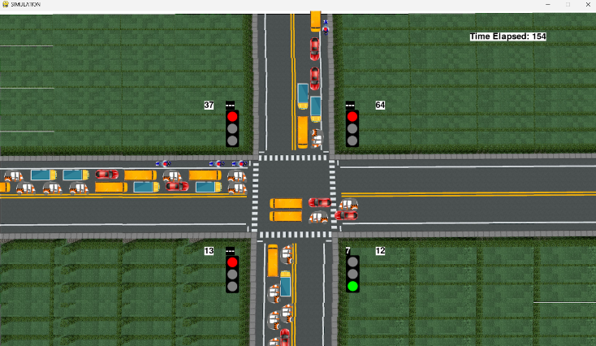

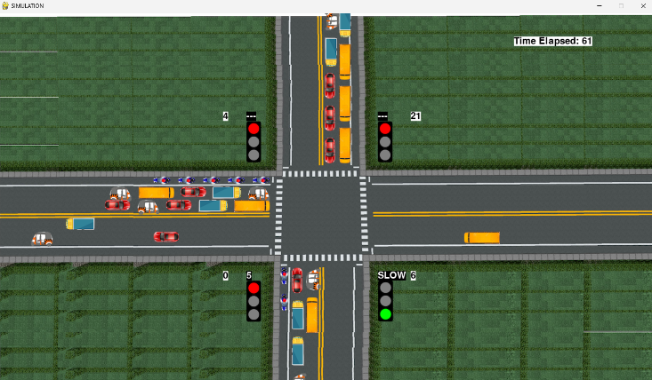

# CONCLUSION

This study showcases how well a Smart Traffic Management System which is a combination of Artificial Intelligence (AI), Internet of Things (IoT), Blockchain (BC), and Machine Learning (ML) can help us to address the problem of today's traffic-related concern. By using effective and adaptive traffic signal regulation and real-time monitoring the proposed Smart Traffic Management System provides an efficient strategy for reducing traffic congestion and helps to improve road safety. The Smart Traffic System can continuously and effectively monitor road conditions and help to identify the risk transmit the data to the concerned authorities and guarantee data integrity across the installed Internet of Things network.

The Smart Traffic Management System's adaptive and efficient control features have helped to create a more sustainable environment by reducing travel time, traffic congestion, and fuel consumption. Furthermore, the Smart Traffic System is an efficient and effective option for upcoming smart city projects due to its scalable design which helps to expand urban infrastructure. This study understates how the use of Artificial Intelligence, Machine Learning, the Internet of Things, and Blockchain can be combined to create an intelligent system that is used to increase road safety and reduce environmental effects. Globally, smarter, more resilient, and more efficient urban transportation networks may be made possible by additional study and development of such a system.

REFERENCES

|  |  |  |
| --- | --- | --- |
| [1]. | Hina, M.D.; Soukane, A.; Ramdane-Cherif, A. Computational Intelligence in Intelligent Transportation Systems: An Overview. In *Innovative Trends in Computational Intelligence*; Springer: Berlin/Heidelberg, Germany, 2021; pp. 27–43. | |
| [2]. | Jelínek, J.; Čejka, J.; Šedivý, J. Importance of the Static Infrastructure for Dissemination of Information within Intelligent Transportation Systems. *Commun.–Sci. Lett. Univ. Zilina* **2021**, *24*, E63–E73. | |
| [3]. | Parihar, M.; Dasari, N.; Bhagwat, K. Intelligent Infrastructure and Transportation: A Case of Passenger Transportation System in Jaipur City of Rajasthan. In *Smart Systems: Innovations in Computing*; Springer: Singapore, 2021; pp. 11–20. | |
| [4]. | Olayode, I.O.; Severino, A.; Campisi, T.; Tartibu, L.K. Prediction of Vehicular Traffic Flow using Levenberg-Marquardt Artificial Neural Network Model: Italy Road Transportation System. *Commun.-Sci. Lett. Univ. Zilina* **2021**, *24*, E74–E86. | |
| [5]. | 1. Bhatia, V.; Jaglan, V.; Kumawat, S.; Siwach, V.; Sehrawat, H. Intellıgent Transportatıon System Applıcatıons: A Traffıc Management Perspectıve. In *Intelligent Sustainable Systems*; Springer: Singapore, 2022; pp. 419–433. | |
| [6]. | 1. Manasseh, C.; Sengupta, R. Middleware to enhance mobile communications for road safety and traffic mobility applications. *IET Intell. Transp. Syst.* **2010**, *4*, 24–36. | |
| [7]. | 1. Choi, J.; Kum, K. Analysis of Mutual Understanding about Dangerous Driving Behaviors between Male and Female Drivers by Co-orientation Model. *J. Korea Inst. Intell. Transp. Syst.* **2018**, *17*, 32–45. | |
| [8]. | Zhang, Y.; Chu, L.; Fu, Z.; Xu, N.; Guo, C.; Zhang, X.; Chen, Z.; Wang, P. Optimal energy management strategy for parallel plug-in hybrid electric vehicle based on driving behavior analysis and real time traffic information prediction. *Mechatronics* **2017**, *46*, 177–192. | |
| [9]. | Kaginalkar, A.; Kumar, S.; Gargava, P.; Niyogi, D. Review of urban computing in air quality management as smart city service: An integrated IoT, AI, and cloud technology perspective. *Urban Clim.* **2021**, *39*, 100972. | |
| [10]. | Silva, P.B.; Andrade, M.; Ferreira, S. Machine learning applied to road safety modeling: A systematic literature review. *J. Traffic Transp. Eng.* **2020**, *7*, 775–790. | |
| [11]. | Gatto, R.C.; Forster, C.H.Q. Audio-Based Machine Learning Model for Traffic Congestion Detection. *IEEE Trans. Intell. Transp. Syst.* **2020**, *22*, 7200–7207. | |
| [12]. | Tubaishat, M.; Zhuang, P.; Qi, Q.; Shang, Y. Wireless sensor networks in intelligent transportation systems. *Wirel. Commun. Mob. Comput.* **2008**, *9*, 287–302. | |
| [13]. | Tubaishat, M.; Zhuang, P.; Qi, Q.; Shang, Y. Wireless sensor networks in intelligent transportation systems. *Wirel. Commun. Mob. Comput.* **2008**, *9*, 287–302. | |
|  | |
|  | |
|  | |